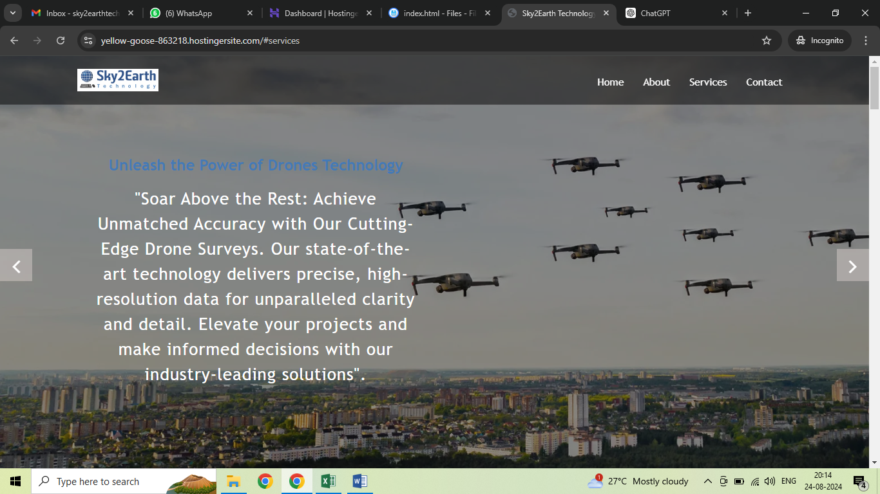

Replace above drone image with below (original image stored in Home Page baner image folder and name given is orthomosaic)

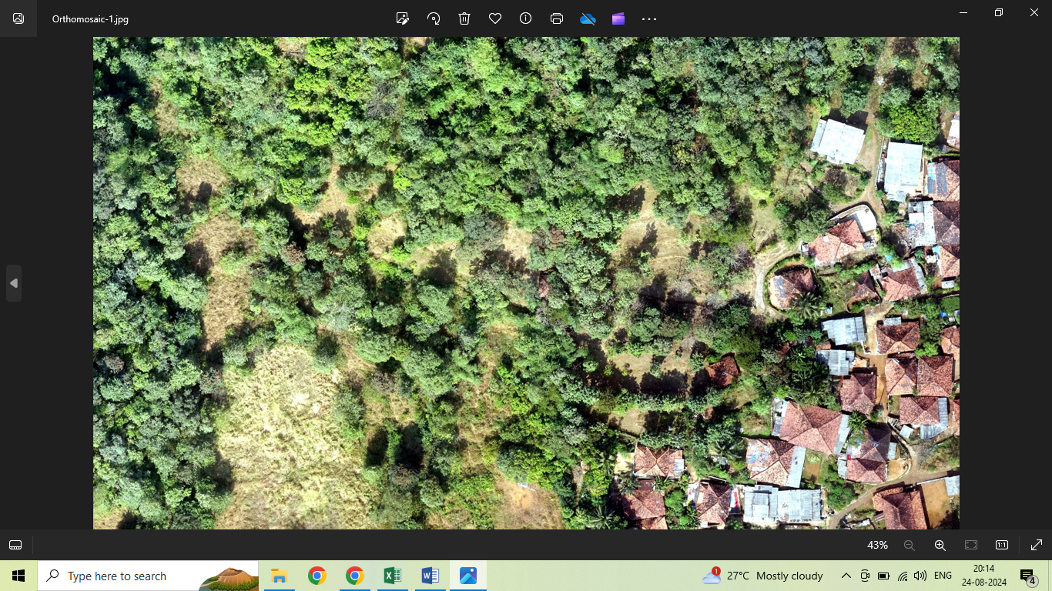

Delete second image baner (keep only 1 and 3)



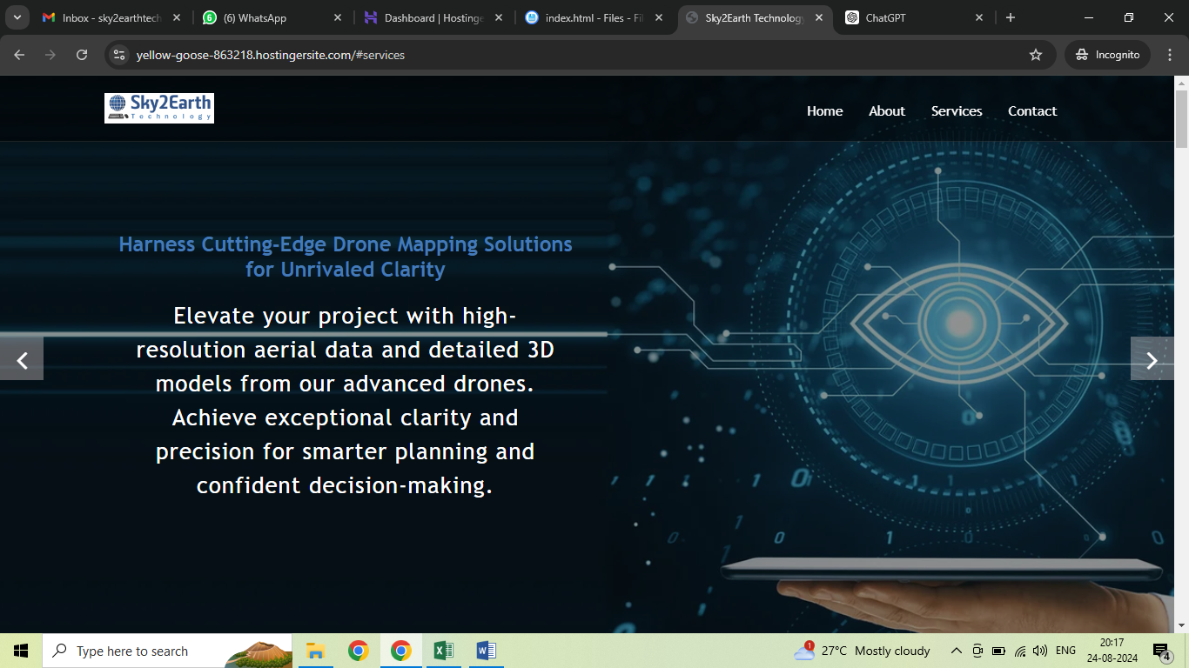

Replace above drone image with below (original image stored in Home Page baner image folder and name given is 3D)

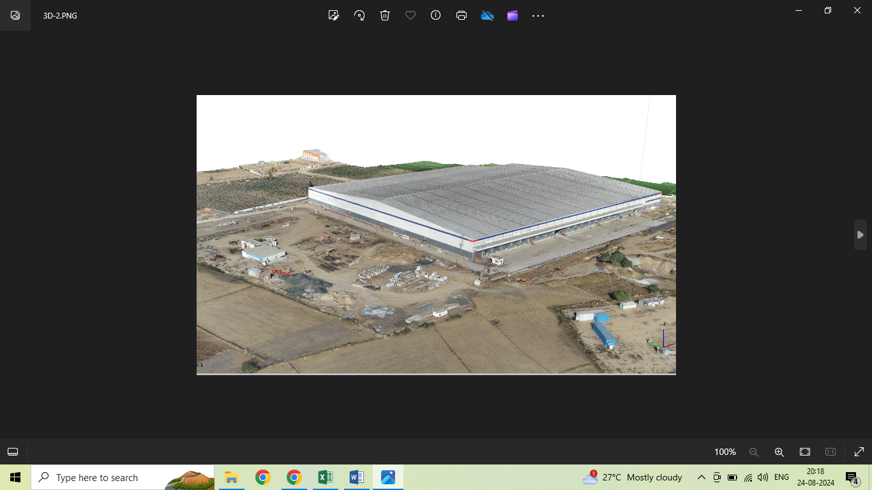

Keep all five (add fifth one R&D)



**Services Section**

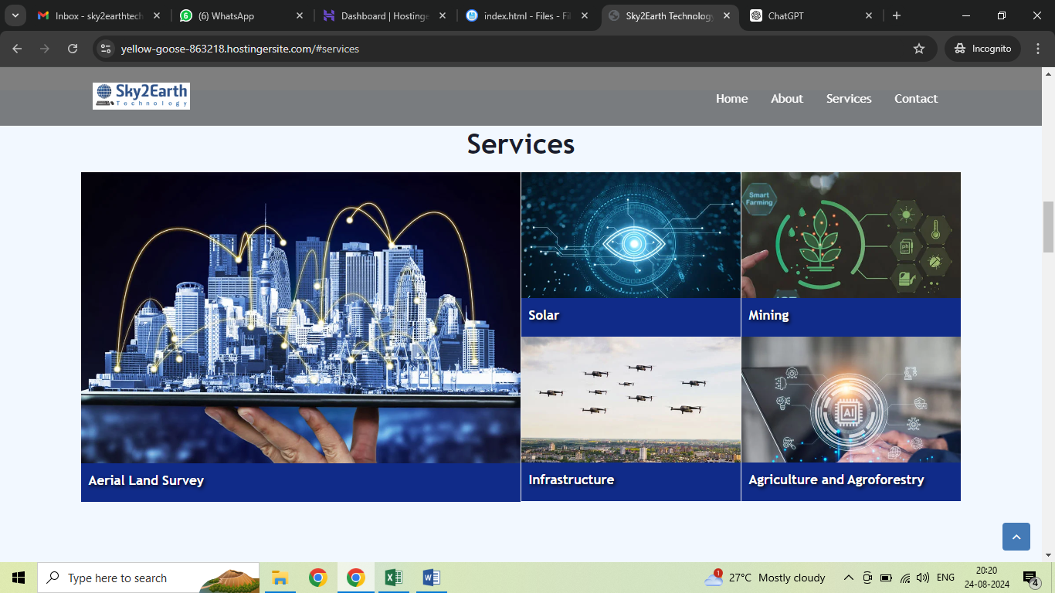

Replace all five images with shared in folder name is Drone and Lidar Survey Survices

